Додоток 1

Різновиди макаронних виробів

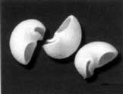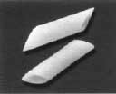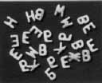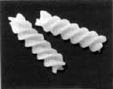

Асортимент макаронних виробів

[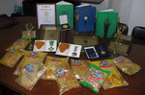](http://krashiy.com/images/expo2007/assets2/photos/8913.jpg)[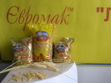](http://krashiy.com/images/expo2007/assets2/photos/8918.JPG)

[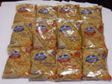](http://krashiy.com/images/expo2007/assets2/photos/8912.JPG)

[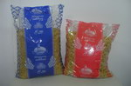](http://krashiy.com/images/expo2007/assets2/photos/8915.jpg)[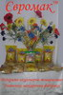](http://krashiy.com/images/expo2007/assets2/photos/8922.jpg)[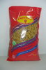](http://krashiy.com/images/expo2007/assets2/photos/8921.jpg)[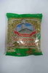](http://krashiy.com/images/expo2007/assets2/photos/8916.jpg)[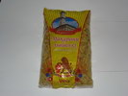](http://krashiy.com/images/expo2007/assets2/photos/8920.JPG)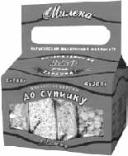[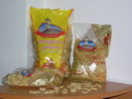](http://krashiy.com/images/expo2007/assets2/photos/8917.JPG)